6. Important Vectors in Public Health

Study Session 6 Important Vectors in Public Health 4
Introduction 4
Learning Outcomes for Study Session 6 4
6.1 Definition of vector 4
6.2 Public health importance of vectors 5
6.3 Vector-borne disease transmission mechanisms 5
6.4 Classification of vectors and their life cycles 6
6.4.1 Arthropods 6
Morphology/structure of insects 7
Reproduction/life cycle of insects 8
6.4.2 Common insect vectors 8
Question 8
Answer 9
Housefly 9
Mosquitoes 9
Question 11
Answer 11
Lice 11
Bedbugs 12
Fleas 13
6.5 Rodents 14
6.5.1 Types of rodent 14
Norway rats (Rattus norvegicus) 14
Roof rats (Rattus rattus) 14
Mice 15
6.5.2 Behaviour of rats 15
6.5.3 Public health importance of rodents 15
6.6 Vector management and control 16
6.6.1 Basic sanitation 16
6.6.2 Physical measures 16
6.6.3 Use of chemicals 17
6.6.4 Biological methods 18
6.6.5 Integrated approach 18
6.7 Planning for the improvement of vector control 18
6.7.1 Knowing the scope of vectors 19
6.7.2 Identifying the extent of the problem 19
6.7.3 Identifying control methods 19
6.7.4 Identifying partners in vector management 19
6.7.5 Designing the plan of action 19
Summary of Study Session 6 19
Self-Assessment Questions (SAQs) for Study Session 6 20
SAQ 6.1 (tests Learning Outcome 6.1) 20
Answer 20
SAQ 6.2 (tests Learning Outcomes 6.2 and 6.4) 21
Matching quiz 21
Solution 22
SAQ 6.3 (tests Learning Outcomes 6.2 and 6.3) 23
Answer 23
SAQ 6.4 (tests Learning Outcome 6.3) 23
Answer 23
SAQ 6.5 (tests Learning Outcomes 6.3 and 6.4) 24
Answer 24
SAQ 6.6 (tests Learning Outcomes 6.3 and 6.4) 24
Answer 24
SAQ 6.7 (tests Learning Outcome 6.5) 24
Answer 24
SAQ 6.8 (tests Learning Outcome 6.5) 24
Answer 25

Study Session 6 Important Vectors in Public Health

Introduction
There are a number of vectors that transmit communicable diseases. Lice, fleas, various types of flies, snails, rats and mosquitoes are widely found in Ethiopia. You learned about some vector-related diseases in the Module on Communicable Diseases. Vectors are found within or close to human habitation; some breed in open water that may be found around homes and others breed inside the home. Certain vectors participate in the destruction of grains and household materials as well. In this study session, you will learn about the types of vectors that are of public health importance, their contribution to disease transmission and measures that can be used to control them.

Learning Outcomes for Study Session 6
When you have studied this session, you should be able to:
6.1 Define and use correctly each of the key words printed in bold. (SAQ 6.1)
6.2 List the vectors that are important for public health in your locality. (SAQs 6.2 and 6.3)
6.3 Describe various environments that support vector breeding. (SAQs 6.3, 6.4, 6.5 and 6.6)
6.4 Name some communicable diseases transmitted by vectors. (SAQs 6.2, 6.5 and 6.6)
6.5 Explain the main methods of vector control that are applicable in a local context. (SAQs 6.7 and 6.8)

6.1 Definition of vector
In ancient times, insects were very important in the transmission of communicable diseases. The definition of vector was then related mostly to insects. Later on the term vector has been used more widely to include other non-human animals including snails, dogs and rats. Alternative definitions are found. For example, vectors can be defined as:
arthropods and other invertebrates which transmit infection by inoculation into or through the skin or mucous membrane by biting or by deposit of infective materials on the skin or on food or other objects.
Ehlers, 1965, Municipal and Rural Sanitation.
This classical definition considers mainly the arthropods (which include insects and other organisms such as mites). It shows the mechanisms of transmission as inoculation (biting) and depositing infective materials (pathogenic organisms such as bacteria) on skin and food.
Vectors can also be defined as any non-human carriers of pathogenic organisms that can transmit these organisms directly to humans. Vertebrates, such as dogs and rodents, and invertebrates, such as insects, can all be vectors of disease.
This second definition focuses on the range of living things involved. Knowing this definition is helpful in the design of preventive measures for controlling living organisms such as insects and rats which carry the disease agent (bacteria, virus) from an infected person to a healthy person.

6.2 Public health importance of vectors
Malaria, yellow fever, typhus fever, epidemic typhus, malaria, onchocerciasis, leishmaniasis, rabies and schistosomiasis are all communicable diseases that are prevalent in Ethiopia. All of these are transmitted by vectors.
Three-quarters of the country is an area of malaria transmission and two-thirds of the Ethiopian population is at risk from malaria. Malaria is the number one illness and cause of human deaths in kolla areas of Ethiopia. A number of diarrhoeal diseases (acute watery diarrhoea, dysentery, typhoid fever) can also be transmitted by vectors and are commonly observed among children in areas where sanitation is very poor. Diarrhoea alone kills many children before they get to their fifth year.
Vector-borne diseases not only cause illness, they also act as a barrier to development. Irrigation and dam workers will not be productive if they get malaria or schistosomiasis (bilharzia or snail fever). A person with malaria will need healthcare and will lose productive days at work. Some diseases like onchocerciasis (river blindness) have a devastating health impact. If onchocerciasis is left untreated the person could go blind. Additionally, vectors like rats destroy food and household materials and weevils damage cereals.
The public health importance of vectors can be summarised as follows:
- They cause illness that could be fatal or restrict working capacity.
- They damage food and household goods.
- They are a barrier to development.

6.3 Vector-borne disease transmission mechanisms
There are two ways that vector-borne diseases are transmitted:
- Mechanical transmission takes place when a vector simply carries pathogenic microorganisms on their body and transfers them to food, which we then consume. Flies and cockroaches are in this category. Flies like to rest on faecal matter and then may move on to fresh food. They can carry infectious agents through their mouth and on their legs and other body parts. They deposit these agents on ready-to-eat foods and the recipient gets infected if they consume the contaminated food.
- Biological transmission involves the multiplication and growth of a disease-causing agent inside the vector’s body.
Malaria is a good example of biological transmission. The female mosquitoes take the malaria infectious agent (Plasmodium) from an infected person with a blood meal. After sexual reproduction in the gut of the mosquito, the infectious agent migrates into the salivary gland of the insect, where it grows in size, matures and becomes ready to infect humans. When the mosquito next bites a human the saliva is injected into the skin and transfers the infection in doing so. An infectious agent may be passed from generation to generation of vector — this happens mostly in ticks and mites.
The methods of transmission for some known vectors are shown in Table 6.1.
Table 6.1 Important vectors and disease transmission mechanisms.
Vector | Diseases | Mechanism
Housefly | Diarrhoeal diseases, TB, polio, worms, food poisoning, infective hepatitis | Mechanical
Mosquito | Malaria, yellow fever, filariasis, dengue fever | Biological
Louse | Typhus fever, relapsing fever, dermatitis | Biological
Mite | Scabies, chigger | Biological
Flea | Plague, murine typhus/endemic typhus | Biological
Sandfly | Leishmaniasis | Biological
Blackfly | Onchocerciasis | Biological
Bedbug | Dermatitis, Chagas disease | Biological
Cyclops | Guinea worm, fish tapeworm | Biological
Tsetse fly | Sleeping sickness (trypanosomiasis) | Biological
Freshwater snail | Schistosomiasis | Biological
Dog | Rabies | Biological

6.4 Classification of vectors and their life cycles

6.4.1 Arthropods
The large group of animals called arthropods includes three main types of organism that are important for the transmission of diseases: insects, arachnids and crustaceans (see Figure 6.1). This section will focus on insects, because they cause major public health problems.
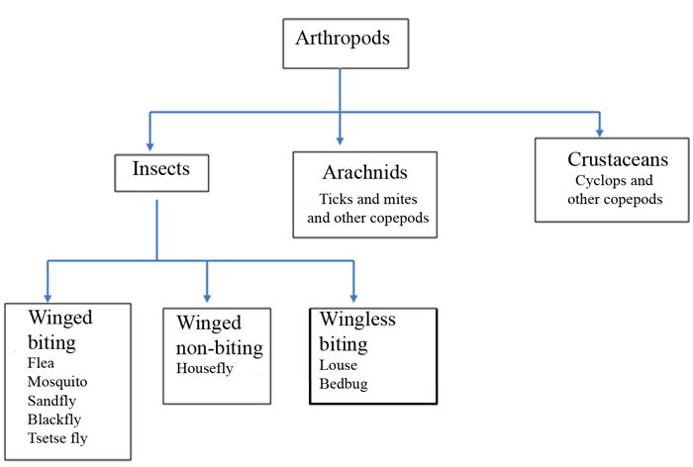
Figure 6.1 Classification of arthropods. (This diagram only shows types of arthropod that are disease vectors. There are many others not involved in disease transmission.)

Morphology/structure of insects
The insect body is divided into head, thorax and abdomen. The mosquito, a typical example, is shown in Figure 6.2. The head has a pair of eyes, antennae, and mouth equipped with sucking or biting parts. The thorax has three joined segments, three pairs of legs, and one or two pairs of wings, although some insects are wingless.
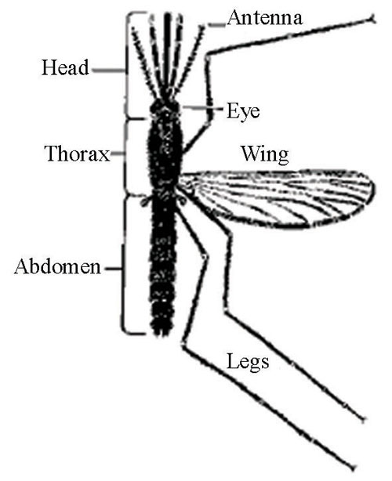
Figure 6.2 Main parts of the adult mosquito. (Source: WHO, 2003, Malaria entomology and vector control)

Reproduction/life cycle of insects
Most insects follow one of two main modes of reproduction. Winged insects, such as the housefly, undergo four stages of development: egg, larva, pupa and adult. There may be several larval stages. Wingless insects, such as lice, undergo three stages: egg, larva and adult.

6.4.2 Common insect vectors

Question
Take a look around your household environment: the kitchen, wastes, walls and clothes. What insect vectors might you find? You may want to ask someone else as well.

Answer
You may have seen houseflies and mosquitoes. Fleas and lice may also be present, although less easy to see.
End of answer

Housefly
We are all familiar with this small creature that disturbs us in and around the household and in workplaces. The female lays 200–250 eggs at a time on organic matter. The organic matter could be human faeces, decaying animal and vegetable matter, fresh food or dung. Eggs are white and about 1 mm long. Within 8 to 48 hours the eggs hatch into tiny larvae. These maggots feed voraciously and pass through the three larval stages rapidly; then after four to eight days they pupate. The pupa gradually hardens and changes colour from yellow through red to brown and finally to black. This pupal stage takes three to five days under optimum conditions. The adult fly is attracted to breeding sites that will provide food and warmth for larvae.
You need to know that there are many different types of fly. Flies that are usually seen around a latrine are different from the common housefly in size and colour. However, they share similar breeding and eating behaviour.

Mosquitoes
There are three main mosquito groups: Anopheles, Culex and Aedes. Anopheles mosquitoes breed in stagnant, relatively clean water bodies; Culex breed in polluted water; and Aedes like relatively clean water. Eggs are laid in a group (150–200 for Anopheles, 200–500 for Culex) on the water surface and hatch into larvae within a few hours. The larvae breathe oxygen from the air and stay at the surface of the water. They feed on organic matter and microorganisms in the water or on the surface. The larva changes into a pupa which can propel itself using paddles at the bottom of the abdomen. The adult mosquito emerges from the pupa on to the surface of the water and then flies away. The duration of the cycle is about 10–14 days depending on the water temperature. The mosquito life cycle is shown in Figure 6.3.
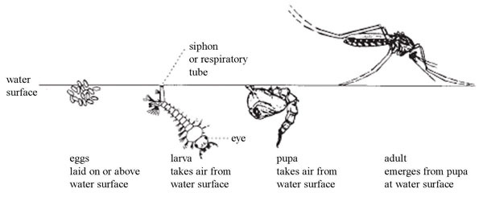
Figure 6.3 Life cycle of the mosquito. (Source: WHO, 1997, Vector control: Methods for use by individuals and communities)
Only female mosquitoes bite and suck blood; the males feed on the nectar of flowering plants. Females are attracted to a host by heat and exhaled carbon dioxide. A blood meal is required before viable eggs can be laid. During feeding on humans, a small amount of anticoagulant saliva will be injected into the host to prevent the blood from clotting. The malaria infectious agent is introduced into the bite site while feeding on blood.
Different species of mosquito carry different diseases. Malaria is transmitted by Anopheles mosquitoes; yellow fever and dengue fever mostly by Aedes. Identification of mosquitoes is difficult without training but breeding behaviour and physical markers can be used to identify the main groups (Figure 6.4).
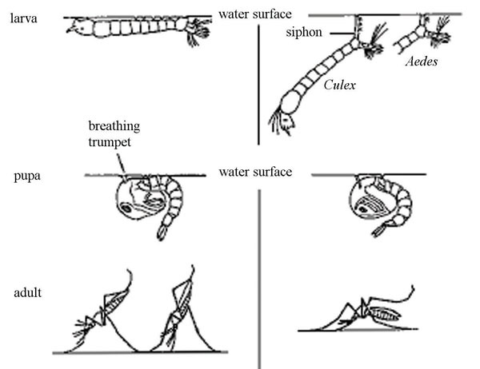
Figure 6.4 Comparison between different types of mosquito: Anopheles (on the left) and Aedes and Culex (on the right). (Source: as Figure 6.2)

Question
What do you notice are the differences between the two types of mosquito shown in Figure 6.4?

Answer
Anopheles adults rest at an angle of about 45 degrees to the surface they are standing on, while adult Aedes and Culex rest with the body parallel to the surface. The opposite is true for the larval resting position in relation to the water level. Anopheles larvae lie horizontally at the water surface but Culex and Aedes hang at an angle below the surface.
End of answer

Lice
There are three types of human louse: the head louse, body louse and pubic louse (see Figure 6.5). All of them are wingless biting insects and live by sucking human blood. They differ in colour and, as their names suggest, in the places on the human body where they are typically found. Head lice are particularly common in children. Being bitten by lice is painful, disturbing and embarrassing, and may cause an allergic reaction.
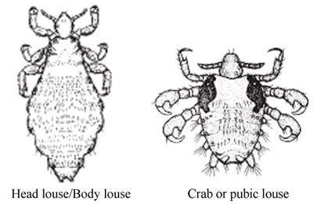
Figure 6.5 Adult lice. (Source: as Figure 6.3)
Head lice eggs are laid at the base of the hair and then hatch, leaving the pale-coloured egg casing, known as a ‘nit’, on the hair (Figure 6.6). The larvae feed on blood until they reach sexual maturity. The life cycle takes about 15 days with laying of about 300–350 eggs at a time. Body lice live in the clothing of the host, especially hiding in the seams. They move towards to the skin of the host to feed. Pubic lice favour the coarser body hair found in the pubic area and armpits.
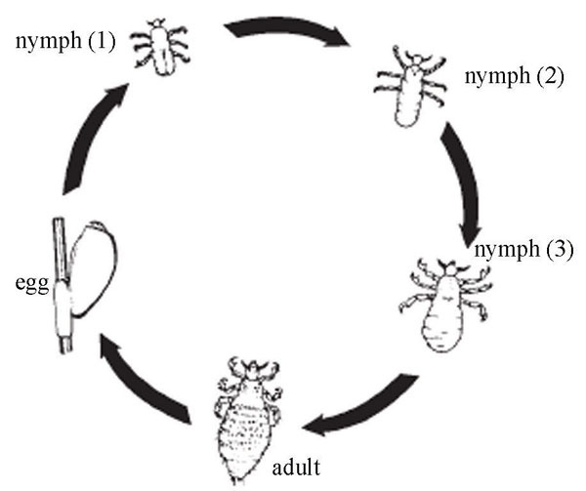
Figure 6.6 Life cycle of the louse. (Source: as Figure 6.3)

Bedbugs
Bedbugs are notorious night-biting insects. They are typically found in houses with poor housing sanitation and are abundant in poor urban and rural areas. They irritate the person while sleeping and disturb the sleep of children. Bedbugs love to hide around the bed and inside crevices of the wall during the daytime, and then become active at night.
Female bedbugs deposit three to eight eggs at a time. A total of 300–500 eggs can be produced by a single bug in a lifetime. They are often deposited in clusters and in cracks, crevices or attached to rough surfaces with a sticky glue-like substance. Eggs typically hatch in a week to 12 days (Figure 6.7). There are five larval stages for bedbugs to reach maturity, which usually takes about 32–48 days. Adult bedbugs can survive for up to seven months without blood and have been known to live in empty buildings for up to one year.
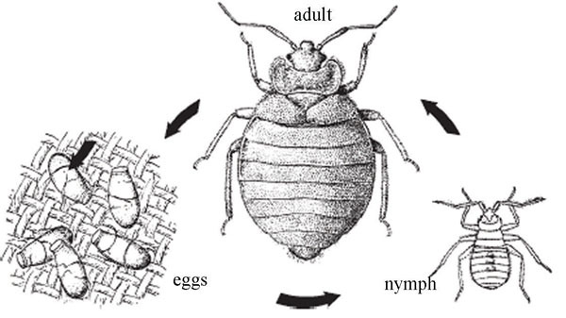
Figure 6.7 Life cycle of the bedbug. (Source: as Figure 6.3)

Fleas
Adult fleas are ectoparasites of warm-blooded animals. There are human, rat, cat, bird and dog fleas, but they can all readily feed on other species in the absence of their primary host.
The prefix ecto- means ‘on the outside’, as opposed to endo- which means ‘on the inside’.
The human flea infests houses with poor sanitation, especially those with a warm, earth floor and dark places. The adults live by biting and sucking blood. The bite is painful, disturbing and irritating. The fleas may be seen on the host animal or on bedding or clothing. More commonly, humans will be alerted to the presence of fleas from the itching that results from being bitten. The bites of cat fleas tend to be confined to the lower legs and ankles, whereas the bites of human fleas tend to be concentrated around the waist and abdomen.
Females require a fresh blood meal in order to produce eggs. Females lay
eight to ten eggs in dark places. The eggs hatch within two days into larvae which feed on organic matter and develop into pupae. The life cycle takes three to four weeks; it is shown in Figure 6.8.
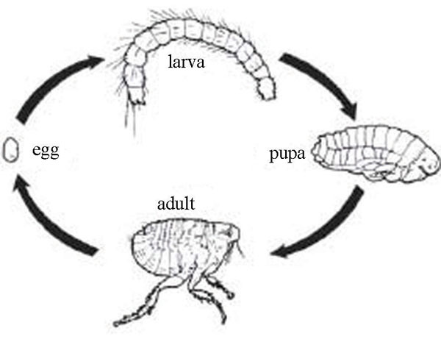
Figure 6.8 Life cycle of the flea. (Source: as Figure 6.3)

6.5 Rodents
Rodents are relatively small mammals with a single pair of constantly growing incisor teeth specialised for gnawing. The group includes rats and mice. Rodents are abundant in both rural and urban areas. They are found inside houses, in fields and around heaps of waste.

6.5.1 Types of rodent
Three types of rodent are commonly associated with public health problems.

Norway rats (Rattus norvegicus)
Also known as the brown rat or sewer rat, Norway rats are most numerous in urban areas. They burrow and live in the ground, and in woodpiles, debris, sewers and rubbish. Norway rats are omnivorous, which means they eat a wide variety of foods, but they mostly prefer cereal grains, meat, fish, nuts and some fruits. They do not travel more than 100 metres in search of water and food. When Norway rats invade buildings, they usually remain in the basement or ground floor. They reproduce rapidly (four to seven times a year producing eight to twelve young per litter with a gestation period of 22 days). The adult is relatively large in size, with a short tail and small ears. Their lifespan is 9–12 months.

Roof rats (Rattus rattus)
Also know as the black or grey rat, roof rats are more numerous in rural areas. They live in roofs, and eat mainly grains. They are smaller than Norway rats with longer tails and ears. They are excellent climbers and usually live and nest above ground in shrubs, trees and dense vegetation. In buildings, they are most often found in enclosed or elevated spaces in attics, walls, false ceilings, roofs and cabinets. They usually nest in buildings and have a range of 30–45 metres. They can often be seen at night running along overhead utility lines or fence tops, using their long tails for balance. The average number of litters a female roof rat has per year depends on many factors but generally is between three and five, with five to eight young in each litter.

Mice
Mice are smaller in size than rats and generally prefer cereals to eat. They are excellent climbers and can run up any rough vertical surface. They will run horizontally along wire cables or ropes and can jump up to 30 cm from the floor on to a flat surface. Mice can squeeze through openings slightly larger than 1 cm across. In a single year, a female may have five to ten litters of about five to six young. Young are born 19–21 days after mating, and they reach reproductive maturity in 6–10 weeks. The life span of a mouse is about
9–12 months.

6.5.2 Behaviour of rats
Rats are active at night. Although the vision of rats is poor, they have keen senses of smell and hearing, and a well-developed sense of touch via their nose, whiskers and hair. They like the same food as people and prefer it fresh, although they will eat almost anything. Rats constantly explore and learn about their environment, memorising the locations of pathways, obstacles, food and water, shelter, and other elements in their domain. They quickly detect, and tend to avoid, new objects placed in a familiar environment. Thus, objects such as traps and baits are often avoided for several days or more following their initial placement. While both species exhibit this avoidance of new objects, it is usually more pronounced in roof rats than in Norway rats.

6.5.3 Public health importance of rodents
Rodents cause a number of problems:
- Disease transmission: rats are the natural hosts of fleas that may carry bubonic plague and murine typhus or endemic typhus from an infected rat to a human.
- Food damage: mice and rats will eat stored food, mainly grains, and will spoil food by leaving their droppings. One rat can consume 15 kilograms of food per year. Rats are estimated to destroy 20% of the world’s crop production.
- Material damage: gnawing by front teeth to doors, windows, wood, boxes, bags, clothes, etc.

6.6 Vector management and control
Vectors can be controlled using various methods. Here we describe the basic methods.

6.6.1 Basic sanitation
This approach targets the elimination or reduction of that part of the environment that facilitates breeding and harbourage (places where vectors find refuge or shelter). It includes the elimination of all possible breeding places for insects, the prevention of stagnation of water to limit the breeding of mosquitoes, and proper solid waste management and use of a latrine to control the breeding of houseflies. The use of clean water from protected sources for drinking prevents the transmission of guinea worm. Rats are controlled by starving them and eliminating their breeding places. Personal hygiene contributes to the control of lice.
Generally, a clean home and environment will prevent the breeding of insects. The use of ventilation, latrines and adequate water supply play a significant role in the control of insects.

6.6.2 Physical measures
These include methods that stop vectors from getting into close contact with humans, and methods that are used to kill vectors. They include bed nets for mosquitoes and wire mesh for flies and mosquitoes Mosquito larvae can be controlled in some water containers by putting a thin layer of used oil on the surface of the water. This acts as a barrier between the water and the air so the larvae cannot access oxygen, and suffocate. Physical methods also include traps such as adhesives to control flies and traps for rats and mice (Figure 6.9). Delousing by boiling or steaming infested clothes are physical methods for controlling lice.
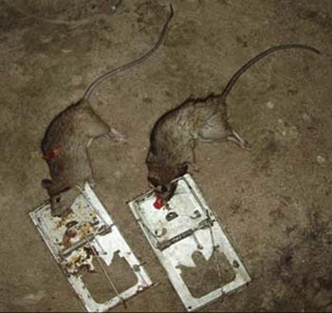
Figure 6.9 Rat trapping (urban roof rat). (Photo: Abera Kumie)

6.6.3 Use of chemicals
Chemical insecticides can be used for the destruction of adults and larvae of insects. Commonly used chemicals are DDT, malathion and pyrethrums. Pyrethrum-containing aerosols are used for the destruction of cockroaches and flies in our homes (Figure 6.10). Rodenticides can be used to kill rats and mice. The indiscriminate use of these chemicals, however, could have undesired health effects on users and domestic animals. Extreme care should be taken during the application and storage of chemicals. It is always important to look at the instructions for using the chemical. Environmental health workers and veterinary technicians may be able to assist in the use of chemicals against vectors.
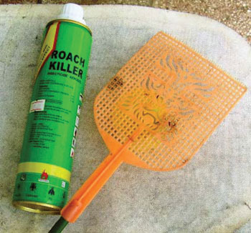
Figure 6.10 Insect killer chemical insecticide and fly swat. (Photo: Abera Kumie)

6.6.4 Biological methods
These include several very advanced methods that prevent the successful reproduction of pest species. They include the sterilisation of males (tsetse fly, mosquito), sex distortion or replacement of genes. All of these methods are expensive and often complex to monitor. Other biological methods involve introducing or encouraging predators of the vector species. For example, small fish can be used to feed on larvae of mosquitoes. Reptiles, birds and frogs feed on adult insects and cats will prey on rats.

6.6.5 Integrated approach
Integrated vector management includes a combination of two or more of the above methods. This is often more effective than using a single method of control. For example, the rat population may be significantly reduced by combining starving with trapping. Sanitation can be combined with other cheap methods in order to be both sustainable and effective.

6.7 Planning for the improvement of vector control
The community may seek your advice on vector management. There are situations where epidemics could be possible because of vectors such as lice and fleas. The following activities are required in order to have good planning in vector management.

6.7.1 Knowing the scope of vectors
You cannot tackle all types of vectors. However, you can be involved in the control of flies, lice, fleas, bedbugs and rats, which are the most important public health vectors. You will probably also be involved in mosquito control.

6.7.2 Identifying the extent of the problem
Knowing the depth of the problem is important in order to mobilise the necessary resources to deal with it. This will also help you in setting priorities for vector control. You need to visit a few dwellings and ask which vectors disturb the family. You should find out how common each vector is in the community.

6.7.3 Identifying control methods
Vector control methods vary depending on the species and you will need to use appropriate methods of intervention according to the above descriptions. Pay attention to breeding site control through the provision of basic sanitation. The use of sanitation, with one or more other methods, is the preferred tool of intervention.

6.7.4 Identifying partners in vector management
You will probably need to liaise with other people and offices to tackle vector problems. These may include local government institutions (for example, the police office for prison lice management; the school office for nits and lice management among students), local NGOs, and community institutions (idir, traditional leaders). They could provide resources and advice, and help mobilise the people.

6.7.5 Designing the plan of action
This requires the preparation of activities under a specified timeframe based on the identified problems. Such activities include: visiting houses, advocacy, public and individual education, and conferences. Your approach to preparing a plan of action for vector management should be similar to other action plans you have learned about in previous study sessions of this Module.

Summary of Study Session 6
In Study Session 6, you have learned that:
- A vector is a non-human carrier of communicable diseases. Arthropods such as insects, and mammals such as rats, play major roles.
- The public health importance of vectors is related to disease transmission, damage to food and property, and acting as a barrier to development.
- There are mechanical and biological methods of disease transmission by vectors.
- Insects are identified by their body structure and the presence of three pairs of legs. Insects go through three or four stages to complete their life cycles.
- Rats are vectors that inhabit and breed inside a house. They are involved in the transmission of diseases, destroying materials and damaging food. There are different methods to control them.
- Vectors can be managed using simple control methods such as sanitation and also physical, biological and chemical methods of control. An integrated approach using sanitation in combination with others is the best option in order to effectively reduce the vector population.
- Planning activities for vector management on an annual basis is one major task of the health practitioner.

Self-Assessment Questions (SAQs) for Study Session 6
Now that you have completed this study session, you can assess how well you have achieved its Learning Outcomes by answering these questions. Write your answers in your Study Diary and discuss them with your Tutor at the next Study Support Meeting. You can check your answers with the Notes on the Self-Assessment Questions at the end of this Module.

SAQ 6.1 (tests Learning Outcome 6.1)
Which of these statements is false? In each case, explain why it is incorrect.
A All arthropods have six legs and a body divided into three parts, namely the head, thorax and abdomen.
B Diarrhoeal diseases can be transmitted to humans by houseflies.
C Transmission of a disease to a human by a biting insect is called mechanical transmission.
D Rats can transmit bubonic plague to humans by eating and contaminating stored food, especially grains.

Answer
A is false. Insects have six legs and a body divided into head, thorax and abdomen. Arthropods are a larger grouping that includes insects but also includes many others such as arachnids and crustaceans.
B is true although diarrhoeal diseases can also be transmitted to humans by direct consumption of infected food or contaminated water.
C is false. Transmission by a biting insect is an example of biological transmission.
D is false. Fleas are the vectors of bubonic plague and their natural host is the rat. A person must be bitten by an infected flea to get the disease. Rats will eat stored food but that is not the mechanisms for transmitting bubonic plague.
End of answer

SAQ 6.2 (tests Learning Outcomes 6.2 and 6.4)
Match the diseases with the respective vector.

Matching quiz

Options
Diarrhoea

Endemic typhus

Malaria

Rabies

Relapsing fever
Typhus fever

Matches
Anopheles

Dog

Flea

Fly

Louse

Solution

Pair 1
Endemic typhus

Flea

Pair 2
Diarrhoea

Fly

Pair 3
Malaria

Anopheles

Pair 4
Relapsing fever
Typhus fever

Louse

Pair 5
Rabies

Dog

SAQ 6.3 (tests Learning Outcomes 6.2 and 6.3)
Visit five to ten households in your area. Observe and ask what environment and behaviour supports the breeding of vectors. List the commonly found vectors that the members of the household complain of. Prepare a checklist for vector assessment that can be used for field investigation.

Answer
Your answer will depend on the situation in your locality but may include poor personal hygiene (dirty clothing, unwashed body) for lice infestation; unclean floor, unplastered walls and poor ventilation for fleas; stagnant water for mosquitoes; cracks on the wall for bedbugs.
Possible checklist for vector assessment:
Name of vector | Breeding site | Number of affected households
Housefly
Flea
Louse
Mosquito
Rats
End of answer

SAQ 6.4 (tests Learning Outcome 6.3)
Visit a place in your locality where there is standing water such as a pond, stagnant water or slowly moving wastewater. Look closely at the water for at least ten minutes and identify the vectors you observe. Use the pictures that are given in this study session to help with identification.

Answer
You may find the larva and pupa stages of Anopheles species in clean standing water; or Culex in dirty water.
End of answer

SAQ 6.5 (tests Learning Outcomes 6.3 and 6.4)
What specific vector-borne diseases are likely to be found in jails, prisons or army camps? Explain your answer.

Answer
The most likely diseases are typhus fever and relapsing fever, both of which are transmitted by lice. The conditions inside a prison encourage the breeding and spread of lice because the inmates live in close proximity to each other and good personal hygiene may not be possible.
End of answer

SAQ 6.6 (tests Learning Outcomes 6.3 and 6.4)
Houseflies are commonly found in all domestic situations. Describe the breeding environment of the housefly and name the diseases that are transmitted by flies in your area.

Answer
Fresh dung (cow, ox, donkey, horse, mule), human excreta and decaying vegetables are all good organic matter that supports the breeding of houseflies. Diarrhoeal diseases are carried by flies.
End of answer

SAQ 6.7 (tests Learning Outcome 6.5)
Imagine that a local householder has a problem with rats and has consulted you for advice. What methods of vector control would you consider recommending?

Answer
The first step in control of rats is to locate their breeding places and clean up any waste or debris that the rats are using for food or shelter. The aim is to starve the rats by removing their access to food sources and clearing any possible places of harbourage. Traps may also be useful. You may also have considered the use of rat poison as long as it is used with care.
End of answer

SAQ 6.8 (tests Learning Outcome 6.5)
The woreda administrator asks you to prepare a plan of action for vector management. Describe how you would go about it.

Answer
The key steps in your plan of action for vector management should be:
- Identifying the type and magnitude of health problems caused by vectors.
- Prioritising vectors and identifying their management/control options.
- Identifying partners.
- Implementing the plan of action.
End of answer

